Lab: Python Parallel Programming
Pratik Abhang | 260740150018
Akanksha Jadhao | 260740150004

Exercise 1: ex01_pycuda_vector_scale.py

Program
"""
Exercise 1: PyCUDA Vector Scaling & Memory Management
Requirement: 65,536 float32 elements, alpha=3.5, block=256.
Includes a CPU architectural simulation fallback when CUDA/PyCUDA is unavailable.
"""
import numpy as np
N = 65536
ALPHA = np.float32(3.5)
BLOCK = 256
def cpu_fallback():
# Same 5-step flow: host -> allocate -> copy -> kernel simulation -> host.
x = np.arange(N, dtype=np.float32)
y = np.empty_like(x)
device_x = x.copy()
device_y = np.empty_like(x)
device_y[:] = ALPHA * device_x
y[:] = device_y
expected = ALPHA * x
print("Exercise 1 - CPU architectural simulation")
print(f"N={N}, alpha={ALPHA}, block={BLOCK}, grid={N // BLOCK}")
print("Verification:", np.allclose(y, expected))
print("First 5 output values:", y[:5])
def gpu_run():
import pycuda.autoinit
import pycuda.driver as cuda
from pycuda.compiler import SourceModule
x = np.arange(N, dtype=np.float32)
y = np.empty_like(x)
x_gpu = cuda.mem_alloc(x.nbytes)
y_gpu = cuda.mem_alloc(y.nbytes)
cuda.memcpy_htod(x_gpu, x)
kernel_code = r"""
__global__ void scale_vector(float *y, const float *x, float alpha, int n) {
int idx = blockDim.x * blockIdx.x + threadIdx.x;
if (idx < n) {
y[idx] = alpha * x[idx];
}
}
"""
module = SourceModule(kernel_code)
kernel = module.get_function("scale_vector")
grid = (N + BLOCK - 1) // BLOCK
kernel(y_gpu, x_gpu, ALPHA, np.int32(N),
block=(BLOCK, 1, 1), grid=(grid, 1, 1))
cuda.memcpy_dtoh(y, y_gpu)
print("Exercise 1 - PyCUDA GPU")
print(f"N={N}, alpha={ALPHA}, block={BLOCK}, grid={grid}")
print("Verification:", np.allclose(y, ALPHA * x))
print("First 5 output values:", y[:5])
if __name__ == "__main__":
try:
gpu_run()
except Exception as exc:
print("PyCUDA/CUDA unavailable; using required architectural simulation fallback.")
cpu_fallback()

Output
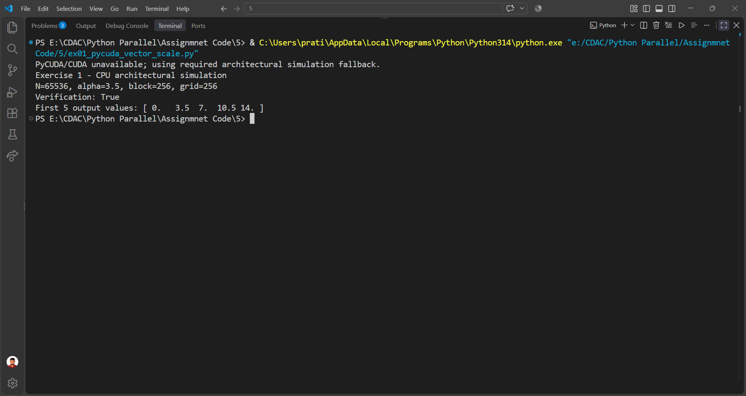

Exercise 2: ex02_pycuda_matrix_transpose.py

Program
"""
Exercise 2: 2D Matrix Transposition Kernel
Requirement: 512x512 matrix, block=(16,16,1).
"""
import numpy as np
N = 512
BLOCK_X = 16
BLOCK_Y = 16
def cpu_fallback():
matrix = np.arange(N * N, dtype=np.float32).reshape(N, N)
output = matrix.T.copy()
expected = matrix.T
print("Exercise 2 - CPU architectural simulation")
print(f"matrix={N}x{N}, block=({BLOCK_X},{BLOCK_Y},1), grid=({N//16},{N//16},1)")
print("Verification:", np.array_equal(output, expected))
print("Corners:", output[0,0], output[0,1], output[1,0], output[-1,-1])
def gpu_run():
import pycuda.autoinit
import pycuda.driver as cuda
from pycuda.compiler import SourceModule
matrix = np.arange(N * N, dtype=np.float32).reshape(N, N)
output = np.empty_like(matrix)
d_in = cuda.mem_alloc(matrix.nbytes)
d_out = cuda.mem_alloc(output.nbytes)
cuda.memcpy_htod(d_in, matrix)
kernel_code = r"""
__global__ void transpose_matrix(float *out, const float *in,
int width, int height) {
int col = blockIdx.x * blockDim.x + threadIdx.x;
int row = blockIdx.y * blockDim.y + threadIdx.y;
if (col < width && row < height) {
int in_idx = row * width + col;
int out_idx = col * height + row;
out[out_idx] = in[in_idx];
}
}
"""
module = SourceModule(kernel_code)
kernel = module.get_function("transpose_matrix")
grid = ((N + BLOCK_X - 1) // BLOCK_X,
(N + BLOCK_Y - 1) // BLOCK_Y, 1)
kernel(d_out, d_in, np.int32(N), np.int32(N),
block=(BLOCK_X, BLOCK_Y, 1), grid=grid)
cuda.memcpy_dtoh(output, d_out)
print("Exercise 2 - PyCUDA GPU")
print(f"matrix={N}x{N}, block=({BLOCK_X},{BLOCK_Y},1), grid={grid}")
print("Verification:", np.array_equal(output, matrix.T))
print("Corners:", output[0,0], output[0,1], output[1,0], output[-1,-1])
if __name__ == "__main__":
try:
gpu_run()
except Exception:
print("PyCUDA/CUDA unavailable; using architectural simulation fallback.")
cpu_fallback()

Output
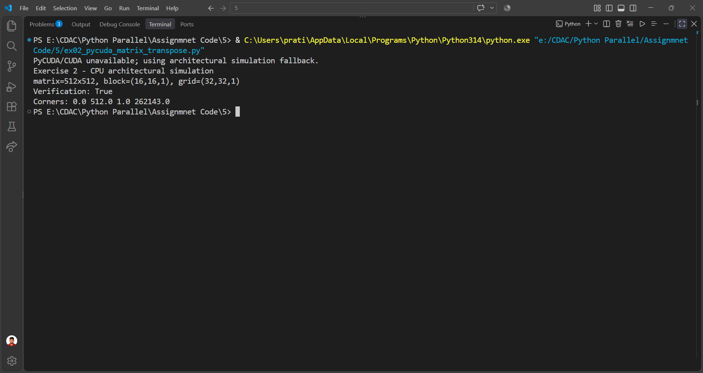

Exercise 3: ex03_gpuarray_expressions.py

Program
"""
Exercise 3: High-Level GPU Arrays & Custom Elementwise Expressions
Requirement: u and v have 500,000 random values.
w = 2*u + 5*v - 1
ReLU: max(0,x)
"""
import numpy as np
N = 500_000
def cpu_fallback():
rng = np.random.default_rng(5)
u = rng.random(N, dtype=np.float32)
v = rng.random(N, dtype=np.float32)
w = 2.0 * u + 5.0 * v - 1.0
expected = 2.0 * u + 5.0 * v - 1.0
relu_input = np.array([-2.0, -1.0, 0.0, 1.0, 3.0], dtype=np.float32)
relu_output = np.maximum(relu_input, 0.0)
print("Exercise 3 - CPU architectural simulation")
print(f"N={N}")
print("Linear combination verification:", np.allclose(w, expected))
print("ReLU input:", relu_input)
print("ReLU output:", relu_output)
def gpu_run():
import pycuda.autoinit
import pycuda.gpuarray as gpuarray
from pycuda.elementwise import ElementwiseKernel
rng = np.random.default_rng(5)
u = rng.random(N, dtype=np.float32)
v = rng.random(N, dtype=np.float32)
u_gpu = gpuarray.to_gpu(u)
v_gpu = gpuarray.to_gpu(v)
w_gpu = 2.0 * u_gpu + 5.0 * v_gpu - 1.0
w = w_gpu.get()
relu_kernel = ElementwiseKernel(
"float *out, const float *in",
"out[i] = (in[i] > 0.0f) ? in[i] : 0.0f",
"relu_activation"
)
relu_input = np.array([-2.0, -1.0, 0.0, 1.0, 3.0], dtype=np.float32)
relu_output = np.empty_like(relu_input)
relu_in_gpu = gpuarray.to_gpu(relu_input)
relu_out_gpu = gpuarray.empty_like(relu_in_gpu)
relu_kernel(relu_out_gpu, relu_in_gpu)
relu_output = relu_out_gpu.get()
print("Exercise 3 - PyCUDA gpuarray")
print(f"N={N}")
print("Linear combination verification:",
np.allclose(w, 2.0 * u + 5.0 * v - 1.0))
print("ReLU input:", relu_input)
print("ReLU output:", relu_output)
if __name__ == "__main__":
try:
gpu_run()
except Exception:
print("PyCUDA/CUDA unavailable; using architectural simulation fallback.")
cpu_fallback()

Output
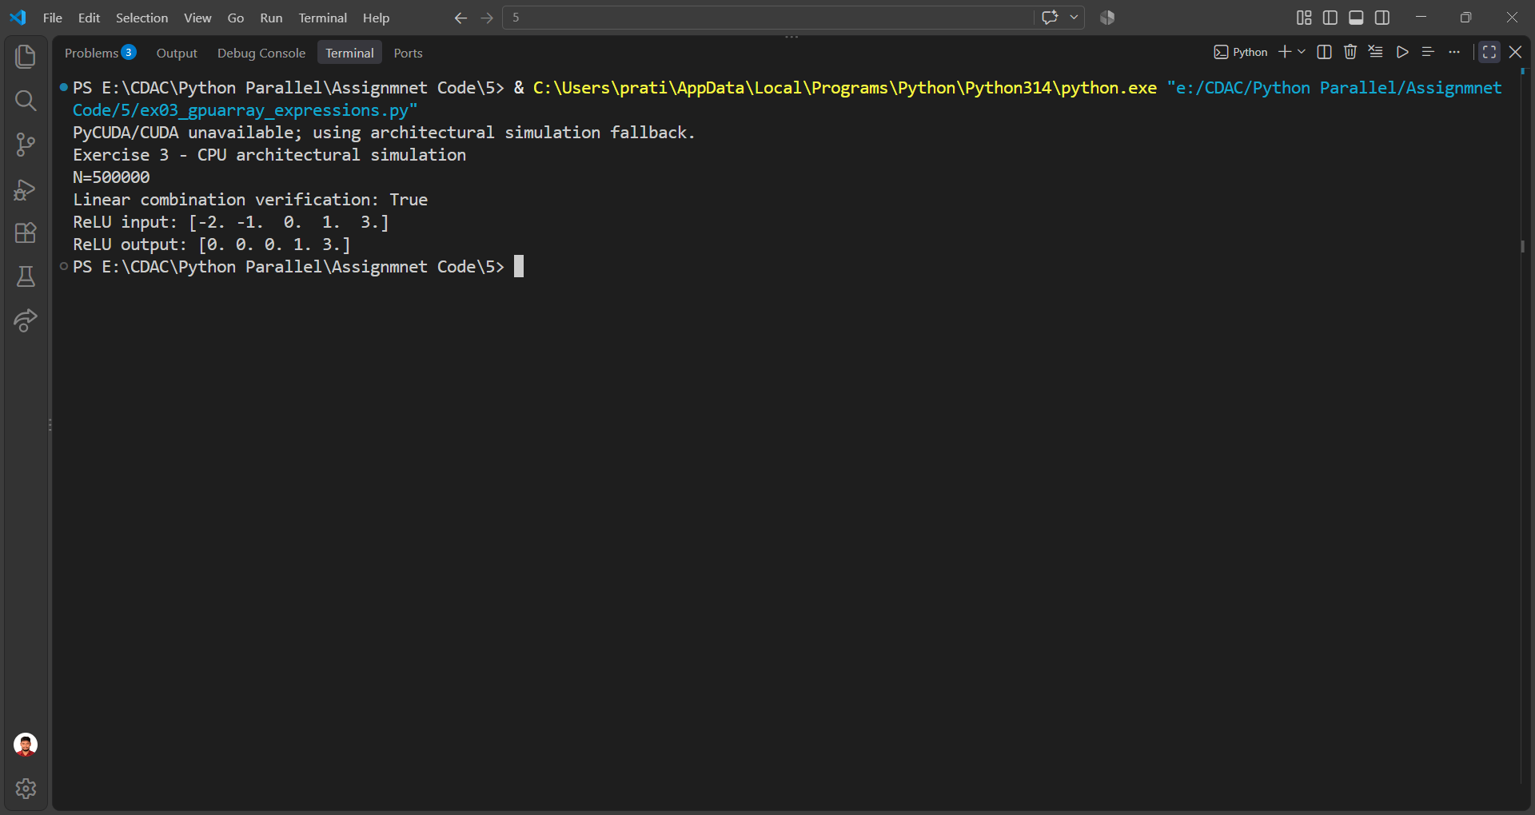

Exercise 4: ex04_numba_shared_memory.py

Program
"""
Exercise 4: Numba CUDA 3-point moving average using shared memory.
The shared tile includes two halo elements so neighboring blocks are handled correctly.
"""
import numpy as np
N = 1024
THREADS = 256
def cpu_fallback():
x = np.arange(N, dtype=np.float32)
y = np.empty_like(x)
y[:] = np.nan
y[1:-1] = (x[:-2] + x[1:-1] + x[2:]) / np.float32(3.0)
expected = np.full_like(x, np.nan)
expected[1:-1] = (x[:-2] + x[1:-1] + x[2:]) / np.float32(3.0)
print("Exercise 4 - CPU architectural simulation")
print(f"N={N}, threads_per_block={THREADS}, blocks={(N + THREADS - 1)//THREADS}")
print("Interior verification:", np.allclose(y[1:-1], expected[1:-1]))
print("First 5 values:", y[:5])
def gpu_run():
from numba import cuda
@cuda.jit
def moving_average_kernel(input_data, output_data):
# Two halo values + 256 block values.
shared_tile = cuda.shared.array(shape=(THREADS + 2,), dtype=np.float32)
t_id = cuda.threadIdx.x
g_id = cuda.grid(1)
if g_id < input_data.size:
shared_tile[t_id + 1] = input_data[g_id]
if t_id == 0:
left = g_id - 1
shared_tile[0] = input_data[left] if left >= 0 else input_data[0]
if t_id == THREADS - 1:
right = g_id + 1
shared_tile[THREADS + 1] = (
input_data[right] if right < input_data.size
else input_data[input_data.size - 1]
)
cuda.syncthreads()
if 0 < g_id < input_data.size - 1:
output_data[g_id] = (
shared_tile[t_id] +
shared_tile[t_id + 1] +
shared_tile[t_id + 2]
) / np.float32(3.0)
x = np.arange(N, dtype=np.float32)
d_x = cuda.to_device(x)
d_y = cuda.device_array_like(x)
blocks = (N + THREADS - 1) // THREADS
moving_average_kernel[blocks, THREADS](d_x, d_y)
cuda.synchronize()
y = d_y.copy_to_host()
expected = (x[:-2] + x[1:-1] + x[2:]) / np.float32(3.0)
print("Exercise 4 - Numba CUDA")
print(f"N={N}, threads_per_block={THREADS}, blocks={blocks}")
print("Interior verification:", np.allclose(y[1:-1], expected))
print("First 5 values:", y[:5])
if __name__ == "__main__":
try:
gpu_run()
except Exception:
print("Numba CUDA unavailable; using architectural simulation fallback.")
cpu_fallback()

Output
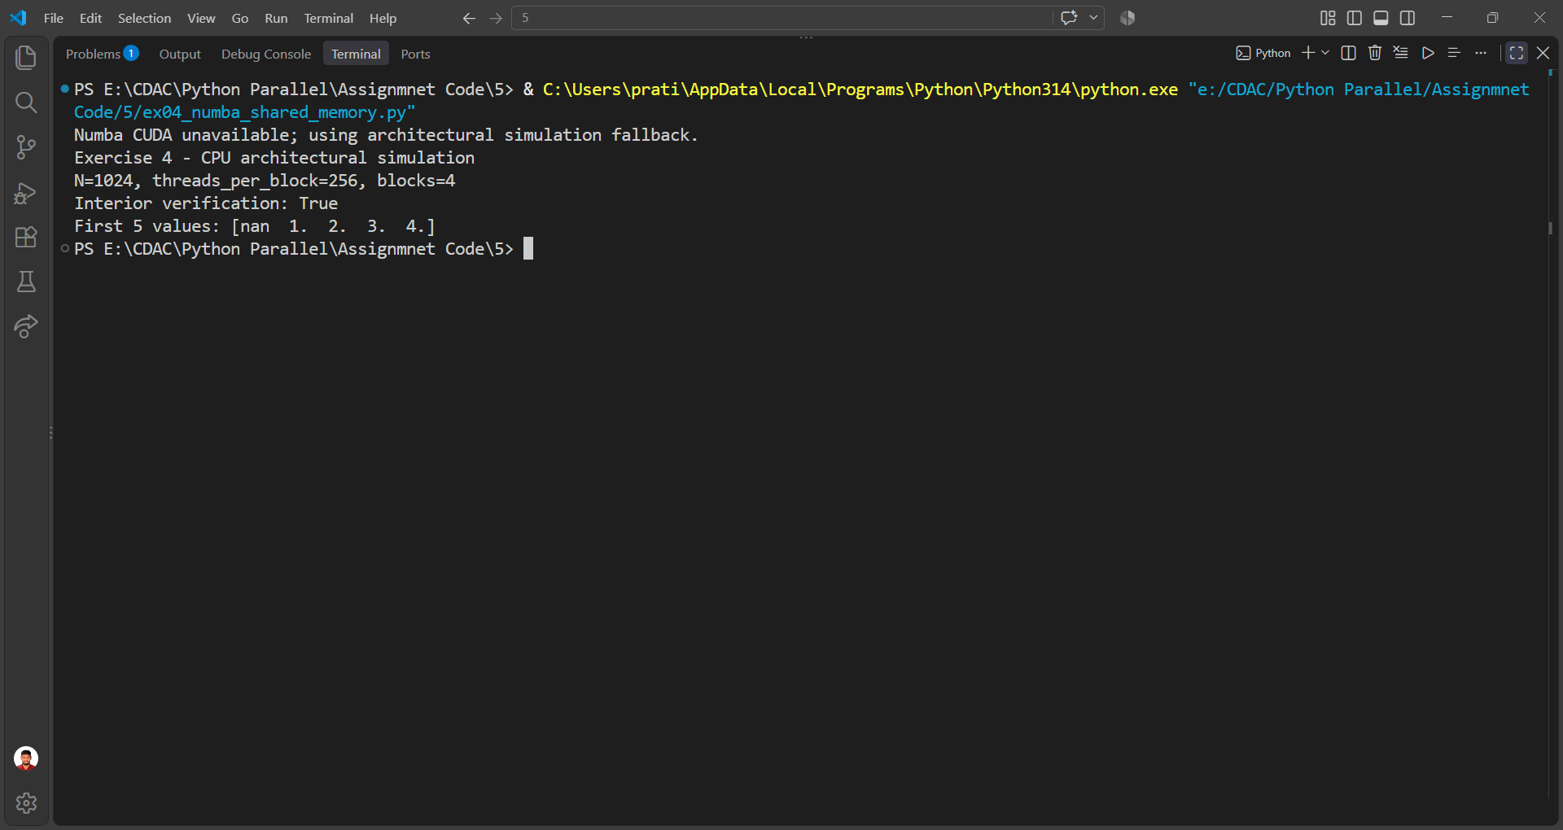

Exercise 5: ex05_pyopencl_runner.py

Program
"""
Exercise 5: PyOpenCL platform/device discovery and vector multiplication.
Uses a simple CPU fallback if PyOpenCL/OpenCL is unavailable.
"""
import numpy as np
N = 100_000
def cpu_fallback():
a = np.arange(N, dtype=np.float32)
b = np.full(N, 2.0, dtype=np.float32)
c = a * b
print("Exercise 5 - CPU architectural simulation")
print("OpenCL platform discovery unavailable.")
print(f"Vector length={N}")
print("Verification:", np.allclose(c, a * b))
print("First 5 output values:", c[:5])
def gpu_run():
import pyopencl as cl
platforms = cl.get_platforms()
if not platforms:
raise RuntimeError("No OpenCL platforms found.")
for plat in platforms:
print("Platform:", plat.name)
for dev in plat.get_devices():
dev_type = cl.device_type.to_string(dev.type)
print(" Device:", dev.name)
print(" Vendor:", dev.vendor)
print(" Type:", dev_type)
print(" Compute units:", dev.max_compute_units)
platform = platforms[0]
device = platform.get_devices()[0]
ctx = cl.Context([device])
queue = cl.CommandQueue(ctx)
kernel_code = r"""
__kernel void vector_mult(__global const float *a,
__global const float *b,
__global float *c) {
int gid = get_global_id(0);
c[gid] = a[gid] * b[gid];
}
"""
program = cl.Program(ctx, kernel_code).build()
a = np.arange(N, dtype=np.float32)
b = np.full(N, 2.0, dtype=np.float32)
c = np.empty_like(a)
mf = cl.mem_flags
a_buf = cl.Buffer(ctx, mf.READ_ONLY | mf.COPY_HOST_PTR, hostbuf=a)
b_buf = cl.Buffer(ctx, mf.READ_ONLY | mf.COPY_HOST_PTR, hostbuf=b)
c_buf = cl.Buffer(ctx, mf.WRITE_ONLY, c.nbytes)
program.vector_mult(queue, (N,), None, a_buf, b_buf, c_buf)
cl.enqueue_copy(queue, c, c_buf).wait()
print("Exercise 5 - PyOpenCL")
print(f"Vector length={N}")
print("Verification:", np.allclose(c, a * b))
print("First 5 output values:", c[:5])
if __name__ == "__main__":
try:
gpu_run()
except Exception:
print("PyOpenCL/OpenCL unavailable; using architectural simulation fallback.")
cpu_fallback()

Output
